Samenvatting Harris 18 (en 20.6)
18.1-3, 18.5, 18.6, 20.6

18.1)
- νλ = c
- E = hν
- 1/λ = wavenumber ↔ E
- De verschillende golflengtes hangen samen met fenomenen die de energie veroorzaken (zie figuur 18.2 voor een overzicht).

18.2)
- Excited state/ground state.
- When light absorbed, P, energy/second/unit area, irradiance of beam decreased.
- Monochromatic = one color.
- Transmittance T:
  - T = P/P₀.
- Absorbance A:
  - A = log (P₀/P) = -log T.
- Absorbance is directly proportional concentration, Beer(-Lambert)’s law:
  - A = εbc. c usually moles/liter, pathlength b centimetres and ε, quantity, is called molar absorbitivity (aka extinction coefficient), tells how much light absorbed certain wavelength, given in /M/cm. Absorbance dimensionless. Also A_{λ} = ε_{λ}bc.
- Absorption spectrum: showing how A varies with λ.
- Chromophore: part of molecule responsible light absorbance.
- Color absorbed → substance seen as complement coloured.
- Beer’s law applies to monochromatic radiation and <0.01M. Not when:
  - When molecules get close properties change.
  - At high concentration dilute becomes solvent → properties change different solvents.
  - Nonabsorbing solutes can also interact absorbing species.
  - Absorbing molecule participates in concentration dependent chemical equilibrium.

18.3)
- Spectrophotometer: light source - monochromator – sample – light detector.
- Cuvet, base line/blank.
- In spectrometric analysis, wavelength max absorption used because:
  - Sensitivity greatest at max absorbance (max response)
  - Curve is relatively flat at max → little variation.
- Spectrometers most accurate at intermediate level absorbance (A ≈ 0.4-0.9):
  - Too little light (high absorbance): intensity hard to measure.
  - Too much light (low absorbance): hard to distinguish difference sample/ref.
- Detection limit by reproducibility measurement.
  - Avoid dust (→ “absorbance”).
  - Filter solution.
  - Cuvet clean.

18.5)
- Molecular orbitals, electronic transition.
- Two possible spin states:
  - opposed: singlet state (lowest is called S₁)
  - parallel: triplet state (lowest is called T₁) (named because of magnetic field)
- Vibrational (>ΔE) and rotational (< ΔE) energy levels.
- What happens to absorbed energy:
  - Vibrational relaxation (to lowest vibrational level) by radiationless transition (trough collisions, e.g. with solvent): heat spread to the medium.
  - Internal conversion: enter highly vibrational level of S_{n-k}. (From here on relaxation).
  - Intersystem crossing: e.g. from S₁ to T₁.
  - Relax by emitting a photon
    - S₁ → S_{o}: fluorescence
    - T₁ → S_{o}: phosphorescence.
    - Lifetime of fluorescence shorter then phosphorescence. (lifetime: time needed population decay to 1/e)
Relative rates depend on molecule, solvent and conditions (T, P). Fluor- and phosphorescence relatively rare.

18.6) Luminescence
- Luminescence: emission of light from an exited state of a molecule (e.g. fluorescence & phosphorescence).
- Luminescence more sensitive absorption (absorption vs. background harder to detect luminescence vs. background).
- Emission spectrum: exciting λ constant, intensity emitted vs emitted wavelength.
- Excitation spectrum: measuring emitted λ constant, intensity emitted vs exciting λ.
- Detector response varies λ.
- At low analyte [] emission proportional (formulas: p. 396).

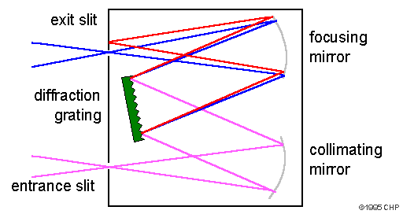
20.6) Choosing monochromator bandwith
- Monochromator bandwidth (#λ; ≠ wavelength) 1/5 peak gives peak shape, largest possible preferred.

